Whiteshell Community Club
PR 301-10 HWY 301
PO Box 190
Falcon Lake, Manitoba
R0E 0N0
May 6, 2018

To Whom it May Concern;

Advertising Opportunity

The Whiteshell Community Club is looking for sponsors to support our club. In return you will receive an advertising spot on our website, www.whiteshellcommunityclub.ca.
For the low cost of $40 a year your business logo or business card will appear on the homepage of our website; interested viewers may click on your logo or business card and be redirected to your website or Facebook page. Receipts will be issued so that your business is able to expense the cost as advertising, thus reducing your next income taxes payable.
Our website has been redevelopment in January of 2018. Since our launch we have had regular visitors come to our page; attached are website stats for your review. We will be working towards another re-design in the fall of 2018 to included an up to date look for our page. To test the effectiveness of advertising, I have created a business, Whitwell Accounting & Bookkeeping, with the sole purpose of seeing how many people visit the website as a result of clicking on the link on our website; attached are website stats for Whitwell Accounting & Bookkeeping.
Thank you for taking the time to review this letter. The Whiteshell Community Club is committed to providing recreational services to people of our community. For further information or to advertise please contact Natalie Rogers via email at n.whitwell@hotmail.com or by phone at 204-679-2643.
Regards,

Natalie Rogers
Communications Director
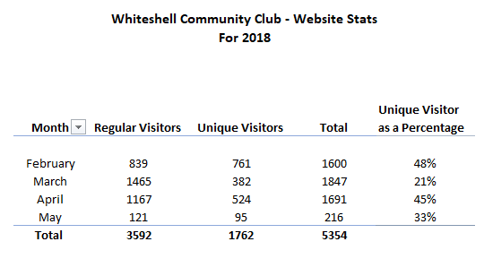

Note: May stats only include the first week of May.

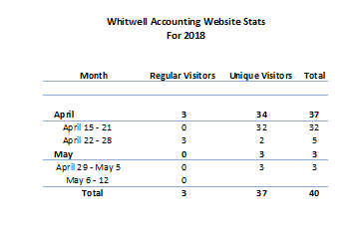

Advertising Application – Whiteshell Community Club Website

Company Name ____________________________________

Contact Person ___________________________
Position ________________________________

Company Address _________________________________________________________________________________________________________________________________________________________________________

Phone Number ___________________________ Email Address ____________________________

Website Address _________________________
Facebook Address ________________________

Do you wish to have a link redirected to your Facebook or Website?

Are you paying by? Cheque Cash Etransfer

- Cost is $40 per year paid annually. Can be paid by cheque, cash or etransfer (Note: call or email Natalie Rogers at 204.679.2643 or n.whitwell@hotmail.com to make arrangements for etransfer)
- Insert or email copy of photo to be upload to our website. (Can be business card, logo, graphics, ad)
- Submit this form and payment to;
Natalie Rogers
Att: Advertising
PO 81
Falcon Lake, MB, R0E 0N0
- Receipts will be issued and mailed

